**Effective modern shell repair techniques for turtles.**

**Author: David Vella**

**Introduction**

Shell injury is one of the most common presenting problems encountered in wild freshwater turtles. These injuries appear to arise mostly from road traffic accidents, but can also result from predator attacks. Occasionally, pet turtles endure shell fractures after falls, as they’re avid climbers, or after being dropped or trodden on.

Shell injured turtles can be very difficult and time-consuming to repair and manage. The length of time in care that’s required for sufficient healing can be upwards of 1-2 years.

One of the biggest problems with managing shell wounds in semi-aquatic turtles is wound care - specifically maintaining the turtle out of its usual water environment. This is due to the fact that aquatic turtles generally require immersion in water to eat and drink.

This article aims to explore some of the basic principles of shell repair in freshwater turtles. It will look at the varied approaches to shell repair and examine the overall management of the turtle in this phase of healing, and explain how the necessity of keeping fracture sites ‘water-free’ can be overcome. .

**Basic turtle biology and anatomy**

Turtles belong to the order Chelonia, which includes both turtles and tortoises. The most frequently encountered native Australian freshwater turtles are semi-aquatic animals. This separates them from tortoises which are terrestrial animals. There are no tortoises native to Australia. There are at least 30-40 species (including sub-species) of freshwater turtles found in all mainland states and territories of Australia, while some species have not yet been fully described 3,29. There are no freshwater turtles native to Tasmania (see table 1).

Knowledge of basic anatomy of turtles may assist in the management of these cases. Turtles have a hard bony casing enclosing their vital organs. The dorsal part of the shell is referred to the carapace, the ventral part the plastron. The section of shell linking these two may be referred to as the bridge. The shell is comprised of dermal bone covered with a tough keratin layer 25. The dermal bone of the shell consists of at least 60 bones derived from modified pectoral and pelvic limb bones, vertebrae, sacral and costal bones 25. The carapace also incorporates the vertebral column (trunk and sacral vertebrae) which runs along its ventral surface. Both the pectoral and pelvic girdles are attached to both the carapace and plastron providing the shell with further strength. Turtles lack a diaphragm. The internal surface layer of the shell can be termed the pleurocoelom or coelomic membrane. Muscles also attach and insert onto the inner surface of the shell. Hence movement can be hindered by some shell fractures, whilst muscular contraction itself may cause movement of a fractured shell segment.

The horny keratin layer covering the bony shell is comprised of individual scutes (also termed scales or shields) which are shed intermittently. The scutes are epidermal in origin, similar to scales of other reptiles. The scute patterns are particular for a species, but do not correspond with the underlying bony sutures of the shell. Scutes can be named and numbered. This allows any shell injury to be anatomically described in terms of location, extent, etc, see figures 1 and 2. Note that some individuals have variations in the overall scute pattern. The shape of the shell can also vary widely amongst different species. Coupled with the fact that scute patterns also vary between species, it may be difficult to draw comparisons of surface injuries to potential underlying injuries between the species.

The exact nature of blood flow through the shell has not been fully described and is likely to vary amongst the different species.

**Overall care of the injured turtle**

There are many issues to consider in turtles with shell fractures. How an injured turtle is managed will depend on a number of factors 31 (see table 2). It is important to consider these factors in light of any repair, rehabilitation and care that can be provided.

At initial presentation, injured turtles are likely to be in shock, dehydrated and experiencing pain. Carry out necessary first aid treatment by providing the injured turtle with hydrative/fluid therapy, appropriate temperature provision, analgesia and commence antibiotic cover if there are open wounds. Radiographing a turtle with shell injury is always recommended. This will allow for better assessment of injuries present and may also importantly reveal the presence of gravid status (see figure 3).

The main goals to consider in turtle shell repair and management are:

**1. Begin stabilising the injured turtle at first encounter**.

Weigh the turtle (give fluids, warmth, antibiotics and analgesia. Analgesia can be offered in the form of opiates and/or non-steroidal anti-inflammatory drugs (once hydrated), (see table 3). Attempt to quell haemorrhage if present. Some parts of the shell (in the author’s experience, especially the bridge) can be difficult to stop bleeding. Protect open wounds and stabilise mobile shell areas.

If injuries are confined to the upper carapace only, and there is no evidence of head trauma, then the turtle can be placed into a shallow amount of tepid water (@ 25°C) for 10 – 20 minutes. This may give the turtle sufficient time to drink. The depth of the water should not reach wound areas. This may be useful in cases where the turtle is only mildly dehydrated. Turtles placed into water should be observed closely. It is vital to ensure that there is no evidence of head or neurological dysfunction present as affected animals may drown if they’re unable to lift their heads from their water bath.

Alternatively, parenteral fluids may be necessary. Suitable parenteral fluids to use can include Hartmann’s and 0.45% NaCl + 2.5% glucose in a ratio of 1:2, or 0.9% NaCl (diluted 9:1 with sterile water for injection). These can be administered intravenously, subcutaneously, epicoelomically or intracoelomically. As a rough guide, give fluids at a rate of 2 - 3% of body on a daily basis 24,30. In cases of more severe dehydration, rates as high as 5% bw/day by intravenous fluid therapy are preferred. The author also performs blood transfusions in cases of severe blood loss.

**2. Assess the degree of injury present**.

Have the turtle radiographed as soon as possible. The three standard radiographic views for turtles include dorsoventral, lateral and craniocaudal projections (see figure 4). The presence of other bony fractures may require attention also and/or influence other necessary treatments and rehabilitation methods. Radiography will also determine if the turtle is gravid (see figure 3).

**3. Attend to the wounds**.

Flush wounds, eg, using saline or appropriately diluted chlorhexidine or povidone iodine. Gently debride any surface material. Wound care may initially require regular daily attention. Light wound dressings may be applied, (see further detail on wound care following).

**4. Plan a method of stabilising fractured shell parts**.

There are many methods available (See discussion on managing shell fractures following). Initial shell stabilisation can be achieved with adhesive dressings, sticky tapes and/or other light bandages, eg, vetrap (3M).

**5. Continue supportive care on a daily basis**.

Provide warmth within the turtle’s preferred body temperature (PBT) range by means of heat mats, lamps, globes, etc. Many of these turtles will require a period out of water (see notes on ‘dry-docking’ following). Placing turtles with shell fractures into full immersion in water is not recommended as this may increase the risk of infection at the fracture sites or risk inadvertent leakage of water through a compromised coelomic membrane.

**6. Keep good records.**

Continually assess the turtle’s body condition and body weight throughout its length of time in care.

**Notes on ‘Dry-docking’**

It is often necessary to keep turtles with fractured shells out of water (dry-docked) while the initial stages of shell healing progresses. This may take as little as 2 weeks for very minor injuries or as long as 1 to 2 years for very complicated fractures. Any turtle undergoing injury repair should not be allowed to enter hibernation. The ‘safe’ time to return a turtle to full water immersion may not always be easy to determine. Typically, though, it may be signalled by the presence of sufficient epithelialisation over the fracture/wound area.

It is clear that a turtle kept dry-docked must be provided with means other than water immersion and routine feeding to effectively nourish and hydrate the animal (freshwater turtles generally need to be in water to feed, drink, etc).

Similarly, turtles should be provided with adequate warmth and the ability to carry out appropriate thermoregulation. Species that require UV light access should also have this provided. Dry-docked animals should also be provided with a substrate that minimises the development of plastral pressure lesions. This is perhaps more readily averted by providing them with shredded or crumpled newspaper or newspaper sheets placed over towels as a substrate. These materials can aid in dispersing the weight-bearing load on the plastron and still act as an effective dry absorptive material for excreta.

Regardless of how the turtle is housed, all animals should be kept under quarantine throughout their length of time in care.

There are a range of levels of dry-docking that can be undertaken:

**Level 1. Dry-docking with intermittent periods of full water immersion:**

Some fracture sites may be small enough or accessible enough so that the area can be effectively covered and water-proofed with appropriate dressings, eg, using adhesive dressings such as Opsite Flexigrid or Opsite Incise (Smith & Nephew). This may allow a turtle sufficient time (say 30-60 minutes) each day to be immersed in water to feed, drink, excrete, etc.

**Level 2. Dry-docking with intermittent periods of partial water immersion:**

Turtles with fractures confined to the carapace may offer a managerial advantage. These individuals can usually be immersed in shallow water (not reaching the injured areas) for a short period each day to allow them to feed, excrete, etc. It is important to ensure that turtles in this situation do not try to climb and potentially flip over onto their wound surface.

**Level 3. Dry-docking continuously:**

Turtles with fractures of the plastron or bridge, or those who have injuries that cannot be made waterproof, may need periods of continual dry-docking. This may also apply to turtles that have sustained head injuries. These individuals need to have their nutrition provided by means alternative to the normal method of placing the animal in water. If the dry-docking period is suspected to take only a short period of time (say 2-4 weeks) then depending on the animal’s body condition, feeding may not be essential. Maintaining hydration, however, is always essential. Fluids can be delivered parenterally as stated above.

Turtles that are continuously dry-docked will pass faeces/urine onto the enclosure substrate. There is no need to immerse them into water for them to be able to excrete (even though this may stimulate excretion). However, careful attention should be paid to the cleaning of smeared excrement from the plastron and feet to avoid secondary infections to these areas.

If feeding is necessary (turtle in poor body condition, or needs to be kept dry-docked for longer periods of time, etc), then turtles can be assist-fed by passing a gastric tube from the oral route. Alternatively, a turtle can be fitted with an oesophagostomy feeding tube placed under general anaesthesia (see figure 5). This can make the process of feeding, hydrating and medicating much simpler and ultimately less invasive for the turtle.

An alternative approach is to provide the dry-docked turtle with a specially designed ‘sunken’ water source that only the turtle’s head and neck can access (this is not the same as providing a turtle with a water bowl sitting on the floor of an enclosure - which would be inadequate). This method has been accomplished and developed for long-necked turtles by turtle enthusiast Michael Frith and reptile veterinarian Dr Robert Johnson and is now commonly employed by the author for both long and short-necked species of turtles.

**Managing the Fractured Shell**

**Main aims of shell repair process**

1. Providing the injured turtle with the ability to return to sufficient function for survival in the wild (or for pet turtles, their captive environment)
2. Providing adequate nutritional, hydrative and medical supportive care measures during their time in care
3. Minimising risk of infection of any healing wounds
4. Stabilising any mobile shell fragments and protect any open wounds
5. Carry out regular wound care in support of wound decontamination, granulation and epithelialisation

**The fractured shell repair process**

There have been many techniques described for repair of fractured turtle shells. With the benefit of hindsight, some of these repair techniques have fallen out of favour (eg, epoxies/’fibreglass’). Often, more than one technique may be required on the one animal. Regardless, it is highly advisable to carry out most repairs (especially on displaced fractures) on anaesthetised animals. Moving any fractured shell segments can cause a great deal of discomfort to the conscious turtle and can also risk further injury. It is always important to consider the use of analgesics in these cases.

In any repair process, one of the main aims is to achieve stabilisation of the shell fragments. Any movement between shell segments may lead to a significant delay in the healing process and in severe cases may lead to no healing at all. In the author’s experience, there does not have to be a complete reduction or close union of the broken shell fragments (though this would be more ideal and may help to reduce the required healing time). Union of bony fractures can take as long as 6 to 30 months 25. Spaces left between fractured shell pieces (if pleurocoelomic membrane is intact and remains viable) should granulate, epithelialise and eventually ossify given the appropriate care. Osteogenesis occurs primarily from the pleurocoelomic membrane 21.

In the author’s opinion, most of these fractures should in principle be treated as open wounds. Similarly, it is in the author’s opinion that too many repair techniques have focused on attempting a closure or seal of a fracture site which potentially risks the closing in of dead tissue or infection, or poses a similar danger if tissue viability is lost underneath the seal. The result of this may ultimately lead to the creation of infection of underlying tissue and/or osteomyelitis in the shell and potentially lead to death of the turtle if this is not addressed. Based on this it may be better to treat fracture sites as open wounds rather than attempt to seal them. Allow for, and support the turtle’s own healing process to progress, while attending to any wound infection and contamination issues that may emerge.

**Shell fracture repair techniques**

This section aims to cover some basic shell fracture repair and stabilisation techniques. More complicated techniques for the stabilisation of mobile shell fragments can be achieved by other methods using orthopaedic metal pins, wires, metal plates, screws, bone/dental cements etc, if the fracture is not conducive to simple methods. These methods should only be performed with the turtle under general anaesthesia.

The shell fracture repair process can be broadly divided into two parts. Firstly wound care and secondly fracture stabilisation. Not all shell fractures are unstable, so in these cases, wound care alone may be necessary.

**1. Shell fracture wound care**

Chelonians have a great ability to repair shell injuries and deficits. By complimenting this process with supportive wound care measures (along with providing the necessary supportive care to the injured animal), very large wound deficits may eventually heal. The author commences an antibiotic course of at least two weeks duration in most cases of open shell wounds.

**A. Cleaning, flushing and dressing wounds**.

**Cleaning.**

Initially it may be necessary to copiously flush the wounds to aid in cleaning and decontamination. This is especially so with turtles that have a greater degree of debris, dirt, etc, present on the shell surface. To assist in cleaning fractured shell sites, soft hand scrub brushes (eg, surgical scrub brushes BD E-Z Scrub 205, Becton Dickinson), soft toothbrushes, dampened cloths or sponges can be used (see figure 6). It is not always necessary to clean the turtle’s entire shell surface; however, removing all dirt, mud, etc, may help in preventing wound contamination at a later date. Generally, there is no need to remove commensal algal growth (if present), from the whole shell. However, removing algae from near and over the fracture sites is necessary. A soft toothbrush can be used to remove algae from shells.

**Flushing.**

Initially, wounds should be flushed once to three times daily, depending on the level of contamination expected. The author’s preferred flushing solutions are 0.05% chlorhexidine or 0.1% povidone iodine. These solutions at these concentrations have been shown to produce a good antimicrobial action whilst enhancing the maintenance of tissue viability28,33.

**Dressing**.

Most simply, wet to dry dressing techniques can be employed in the early stages of wound care (see figure 7). These should be changed every 24hrs, with attendance to wound flushing and debriding in between. Various products can be used to dress open contaminated shell wounds. Acticoat (Smith & Nephew), a silver-coated wound dressing and barrier mesh can be applied to the wound surface24. These products can achieve days of antimicrobial activity if used appropriately. Whilst the more commonly used Silvazine cream (Smith & Nephew) may achieve similar results, it may require more regular applications17.

Agents that can be used to promote debridement and sloughing in wounds include IntraSite gel (Smith & Nephew) or Manuka honey (Activ Honey, Nature’s Goodness Australia). Some honey types have been shown to be effective wound management compounds with some antimicrobial action20,33. Iodosorb ointment (Smith & Nephew) also offers a suitable compound to apply to contaminated shell injury sites. Formulated for human use, this hydroscopic compound also offers a sustained release of antimicrobial/non-cytotoxic levels of iodine at the wound surface.

Dressing wounds can at times prove difficult in some locations, eg, bridge fractures. The use of occlusive adhesive dressings may help overcome these difficult areas. Most of these adhesive dressings come as transparent, sterile, air permeable and waterproof sheets in various sizes, eg, Opsite Flexigrid and Opsite Incise (Smith & Nephew), (See figure 8), Bioclusive transparent dressings (Johnson & Johnson) and Tegaderm (3M). These products can prove very useful in protecting wound surfaces or maintaining other dressings, gels, etc. Strategic applications of these can also assist in waterproofing a wound thus allowing a turtle some swim time. Some newer dressings also incorporate antimicrobial compounds such as iodine, eg, Ioban (3M) and Iodosorb sheets (Smith & Nephew).

Minor cracks can sometimes be managed with appropriate wound irrigation alone. Larger cracks can be cleaned and managed by regular dressing changes over the wound area. This should work well as long as stabilisation of the fracture pieces has been achieved.

**B. Debriding wounds.**

Wound debridement often constitutes an important part of shell fracture treatment and repair. The presence of non-viable, infected or contaminated tissue may slow or hinder wound healing. Significant debriding in most cases should be performed under general anaesthesia. Wounds can be cleaned gently with soft scrub brushes as stated above. Suspect soft tissue can be gently cut away. For harder shell tissue, the use of hypodermic needles, scalpel blades, rongeurs, or careful burring with electrical high speed burrs may be utilised. Debrided shell edges should show evidence of fresh bleeding thus indicating viability.

If there are overlapping shell pieces, then attempts should be made to carefully lift these pieces back into realignment (only under anaesthesia). This is not always readily achievable but in some cases may be accomplished by use of hooks made from hypodermic needles or with fine hooked dental instruments15. In cases where realignment cannot be attained, then the overlapping shell fragments should in the author’s experience be cut back to the level of the underlying fractured segment’s edge. This same technique of debriding fractured shells is often employed by the author in areas where underlying pleurocoelom has avulsed from the shell. The pocket or dead space produced by this phenomenon appears to at least complicate and/or delay wound healing in the author’s experience. Therefore, shell fracture segments may in some cases be debrided to the point of their attachment to underlying pleurocoelom. Completing this can render the shell deficit area significantly larger than at initial presentation.

Regardless of how much wound debridement has been achieved, maintaining a healthy wound surface and pleurocoelom appears to provide suitable surface for granulation, epithelialisation and eventual re-ossification to take place (nb, ossification process may take years – if ever – to occur). It may not be essential for a shell deficit to be fully hardened with new bony shell growth for the turtle to be able to function effectively.

**2. Methods of shell fracture stabilisation**

**A. Adhesive tape stabilisation**.

Many simple, mildly displaced fractures with little mobility can be effectively stabilised using adhesive tapes. Some packaging tapes, eg, Tartan Filament Tape 8934 (3M) have fibres embedded within the tape rendering them highly stretch resistant. This particular tape also appears to have a good water-proof and adhesive period (months in some circumstances), (see figure 9).

This form of fixation can work for some types of carapace fractures, especially if the fracture involves the margins of the carapace. It may also be useful as a ‘first-aid’ fixation device, stabilising shell fractures in the short-term until the animal can be anaesthetised for repair.

**B. Bridging fractured segments**.

Fractured shell fragments can be stabilised by means of plate like devices bridging fractured areas27. This form of fixation offers the advantage of allowing access to the fracture site for wound care. This form of stabilisation can be used for short or longer term care of fractured shell segments. Bridging can be achieved most simply by use of adhesives to fix the bridging plates into place. Or, more complex orthopaedic implants such as screws, pins or wires may be utilised as anchoring devices. Bridging may be especially useful for areas where taping could prove difficult or where there is much fracture movement or missing shell fragments.

The author often utilises plastic ‘saddle-clamps’ as bridges. Saddle-clamps are ‘U’ shaped clamps commonly used to secure round pipes to flat surfaces. Any material (metal, plastics, etc, can be used), however the irrigation type plastic moulds may prove more versatile, eg, 4mm and 13mm saddle clamps (Nylex). These clamps can be placed over the fracture site as shown in figures 10 to13. They can be used to secure a mobile shell fragment to a secure/non-mobile part of the turtle’s shell, thus rendering the fracture site stabilised. The plastic clamps have the added advantage of being easy to bend and cut into the shape to fit the contours of a specific shell area. Each flat end of the clamp can then be effectively ‘glued’ to the shell surface (see figure13).

Suitable adhesive glues include the use of ‘5-minute’ type strong glues, eg, 5 minute Araldite adhesive (Selleys), but ensure that no adhesive enters open wounds. The ‘U’ shape of these clamps is important. Once in place, they offer the ability to access the wound while maintaining fracture stability (see figures 11 to 13). The ‘bridge’ that is formed over the wound also allows good visualisation of the healing area and thus aids in monitoring of the wound healing processes. The bridging technique utilising adhesive fixation, in some cases also offers the advantage of being able to be applied to a conscious animal.

Many other materials can be used to achieve similar stabilisation. Other plastic type hook arrangements such as wall hanging hooks, eg, Command Decorating Clips (3M) can be adhered to a shell surface. These can then serve as anchor points for wiring, suture placement, etc. This may allow for a wider bridge to be formed. Mounted cable tie mounts and ties have also been utilised to bridge and subsequently reduce fracture sites7. The design of any metal repair (eg, plates) should ideally include a ‘bridge’ formation over the fracture site so as not to cover the healing area. The glued-on saddle-clamp method offers an alternative simple stabilisation system.

**C. Orthopaedic fixation**.

Other more complex fixation methods (utilising orthopaedic screws, orthopaedic pins, surgical wiring, etc), may need to be employed in some cases, especially in larger or more robust individuals. These always require insertion with the turtle under general anaesthesia. Examples of such fixations include screws, cerclage wires and pin placements2,13,18,21,22,23, (see figure 14). The major disadvantages associated with these methods are in expense, potential for introduction of infection, implant failure and absolute necessity for insertion under general anaesthesia.

In some cases, other forms of external coaptation can be achieved to compliment other fracture stabilisation techniques18. For example, a brace like cast can be moulded (eg, using Vet-lite, Runlite SA) to provide further support around a bridge fracture.

**D. Rigid, occlusive semipermanent dressings.**

This involves the permanent or semi-permanent sealant fixation utilising epoxies, resins, glues, cements, acrylics, etc.Previously, the ‘sealing’ of shell fractures had been an accepted method of repair in aquatic turtles. This would appear to be a logical method of repair given that it provides a stable, waterproof and ‘instant’ patch-up. Historically, the use of epoxy/’fibreglass’ type fixation methods have been employed in the repair of turtle and tortoise shell fractures9,10,14,15,16,35. This method in particular has fallen out of favour due to potential negative mid to long term effects of this procedure2,11. Apart from being potentially toxic, the somewhat permanence of this dressing can lead to such problems as distortion of growth or the sealing in of infection, (see figure 15). The exothermic nature of many epoxies may also risk tissue injury when applied.

Only in sterile wound sites and only after a suitable course of antibiotics has commenced and prior appropriate wound management, should any attempt be made to seal a fracture site. Many different types of wound sealants have now been used, including calcium hydroxide pastes26,34, bone cements, other epoxies, eg: Knead It (Selleys)26, dental glass ionomers8, etc. These repair methods have many disadvantages. Perhaps their single most important problem lies in the potential for the development of cellulitis, soft tissue infection or shell osteomyelitis. This can occur due to any one or a combination of these factors;

1. Sealing in of contamination, debris or infection

2. Sealing in of non-viable tissue

3. Sealing in of tissue that may become non-viable any time after the sealant application36

Apart from this, these sealant techniques do not allow for the inspection of the wound surface nor do they allow for further wound debridement. Similarly, these occlusive dressings do not allow for the natural shedding of the scutes which, on the dressing’s edge, may become a source of water entrapment and subsequent shell rot. These techniques have also been discouraged in marine turtles32. The application of impervious sealants may also hinder wound healing5. Furthermore, the removal of these materials may be prove difficult.

There are few long term studies to show the implications of these semi-permanent/permanent dressings. However, their potential to lead to harmful sequelae cannot be underestimated. It is therefore difficult to recommend most of these compounds in most forms of shell repair techniques for freshwater turtles

**Types of fractures and other complications**

**Depression fractures**.

The effect of a depression type fracture will depend on the location and extent of the fracture. Fractures involving the midline of the carapace or over the pectoral or pelvic girdles may be associated with damage to the spinal column and pelvic/pectoral bones respectively. Damage to viscera may be more difficult to assess. It is important however to recognise that the lungs are attached to the under-surface of the carapace.

Radiographic studies are necessary to assess the degree of underlying damage. The use of advanced imaging such as computed tomography has been used by the author and others and offers the ability to further enhance injury assessment1, (see figure 16). If these fractures appear to be having no affect on the turtle’s function, then they are probably best left as is. Attempts at reducing the depression may result in further injury. It may be necessary to intervene however, if there are overlapping segments or instability of fractured shell fragments.

**Missing shell fragments.**

This is not necessarily a problem, as long as coelomic penetration has not occurred. However this scenario can present a major dilemma in some instances where vital shell areas have been lost. For example, if enough of the cranial carapace edge is missing, it may effectively diminish the turtle’s ability to ‘hide’ its head and neck within its shell upon retraction. This situation may lead to an increase in vulnerability in cases of predator attack.

In some cases, the severity of injury may be more obvious. It can be difficult to repair large holes in the pleurocoelom. Furthermore, these deficits may result in a greater risk of initiating and producing intracoelomic infection. The presence of penetrative coelomic wounds and the visualisation of viscera requires vigorous treatment. Small deficits can be sutured closed with absorbable suture. However the potential for infection can make these injuries difficult to treat. Copious open coelomic lavage and drainage, along with scrupulous wound care and broad spectrum antibiotics are necessary. The presence of large deficits in the pneumocoelom is often used by the author as a guide to warrant euthanasia (see figure 17).

Many turtles appear to be able to cope with parts of their shells missing. This is exemplified by the fact that many are found in the wild with healed shell deficits. There are no hard and fast rules to deciding how much shell missing is too much. Each case needs to be assessed on an individual basis.

**Associated skin wounds.**

Other complications may arise if there are missing shell pieces associated with skin wounds. Turtles may present with the skin near the legs, neck or tail torn away from the carapace, plastron or bridge. This type of injury without accompanying shell fracture in the area can usually be remedied. However reattaching skin to areas where shell pieces are missing or fractured is generally very difficult to achieve. These animals may often carry a poor prognosis.

**Novel techniques and procedures**

There are several newer or less accessible methods that can be employed in the repair and assessment of shell viability and shell fractures in chelonians. Deficits in shell and skin have been repaired using matrix materials that provide a scaffold for tissue granulation to occur. One such product VetBioSISt has been used to such an extent6.

More recently, vacuum assisted healing19, and negative pressure application4 to wounds has been utilised to hasten shell injuries in chelonians. Although more elaborate and initially time consuming, the former method has been shown to reduce wound healing times and potentially shows favourable promise for future development.

Scintigraphy has been utilised as an aid to assess shell viability. This may potentially be a more sensitive technique than radiography12.

As stated earlier, advanced imaging also has a place in a more thorough assessment of injuries in turtles. Computed tomography can especially allow for a better assessment of internal injuries1.

**Conclusion**

There are many factors to consider in shell fracture repair in semi-aquatic freshwater turtles. Apart from offering adequate husbandry, more specific adjustments are needed to cater for a dry-docked turtle. Most shell fractures, in the author’s experience, can be managed as open wounds. Open wound management is likely to offer the least amount of risk of wound complication that could otherwise occur with more traditional wound sealing methods. The method of fracture bridging, in particular, offers a relatively simple application of readily available and inexpensive materials.

**Table 1. Turtle or tortoise? Quick facts on Australian freshwater turtles**

1. Australian freshwater turtles are semi-aquatic animals
2. This separates them from tortoises which are wholly terrestrial animals
3. There are no tortoises native to Australia
4. There are at least 30 to 40 species (including sub-species) of freshwater turtles found in all mainland states and territories of Australia29
5. Some freshwater turtle species have not yet been fully described29
6. There are no freshwater turtles native to Tasmania.

**Table 2. Factors to consider in managing an injured turtle**

1. Which part of the shell is fractured (carapace, bridge, plastron and combinations thereof)
2. Which surrounding structures may be damaged
3. If parts of the shell are missing or ‘non-vital’
4. Presence of pre-existing shell disease
5. Presence of other underlying disease
6. Time of year the turtle has presented (this may play a role in the total body ‘reserves’ present)
7. Overall condition of the turtle
8. Overall size of the turtle
9. How ‘fresh’ or old the injuries are
10. Presence of infection and/or contamination of the wounds
11. Presence of algae (usually commensal) on the shell
12. Possibility of fly-blown status
13. Concurrent head, neck, limb or tail injuries
14. Possibility of gravid status
15. Presence of internal injuries (not easy to determine)

**Table 3. Analgesics for use in Australian freshwater turtles30**

**Drug Dose**

 Buprenorphine 0.01-0.03mg/kg sc, im q24-48h

Butorphanol 0.5-2mg/kg sc, im q24h

Carprofen 2-4mg/kg sc, im q24 -72h (ensure hydrated)

Meloxicam 0.1-0.4mg/kg sc, im q24 – 48h (ensure hydrated)

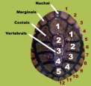

*Figure 1. Names of the individual scutes of an eastern long-necked turtle (Chelodina longicollis) carapace.*

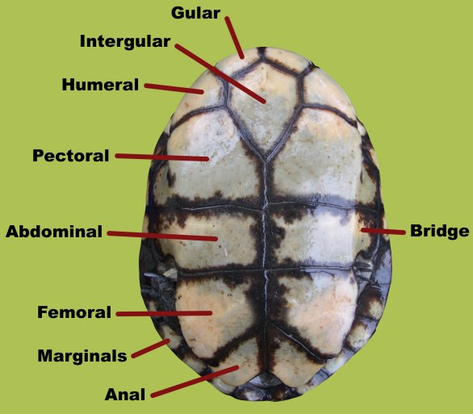

*Figure 2. Names of the individual scutes of an eastern long-necked turtle (Chelodina longicollis) plastron.*

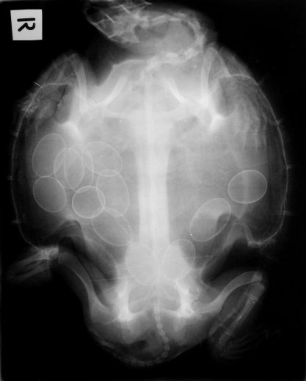

*Figure 3. Radiograph of a Murray river turtle (Emydura macquarii macquarii) showing gravid status.*

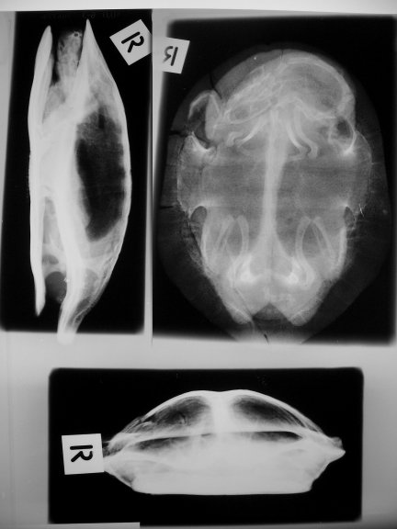

*Figure 4. Three standard radiographic views of a turtle exhibited on one plate. Dorsoventral, lateral and craniocaudal projections.*

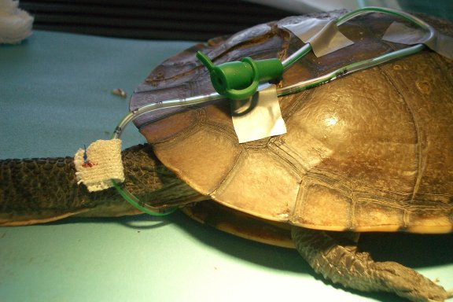

*Figure 5. Placement of an oesophagostomy feeding tube in an eastern long-necked turtle (Chelodina longicollis) can aid in providing hydrative and nutritional support while being dry-docked.*

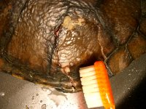

*Figure 6. Cleaning and debriding shell wounds with a soft toothbrush.*

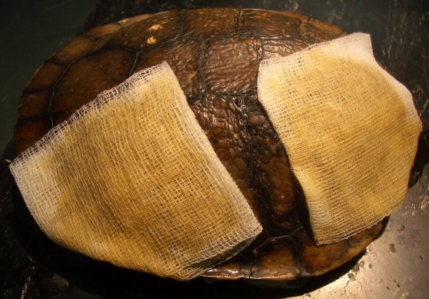

*Figure 7. Wet-to-dry bandaging techniques can be employed in the early stages of fractured shell repair in turtles.*

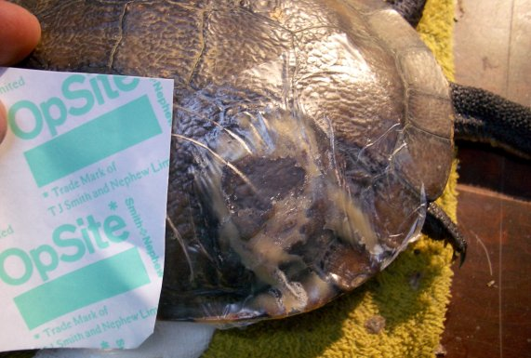

*Figure 8. Application of occlusive waterproof adhesive dressings can aid in the protection of the wound site.*

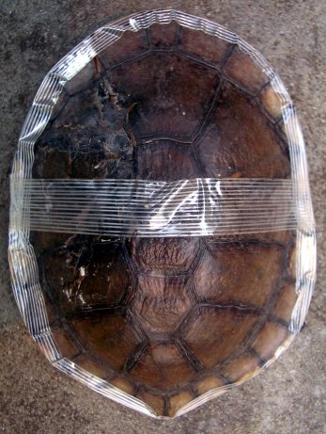

*Figure 9. Eastern long-necked turtle (Chelodina longicollis) with adhesive tape stabilisation of its fractured shell. This form of stabilisation can serve as a good ‘first-aid’ measure.*

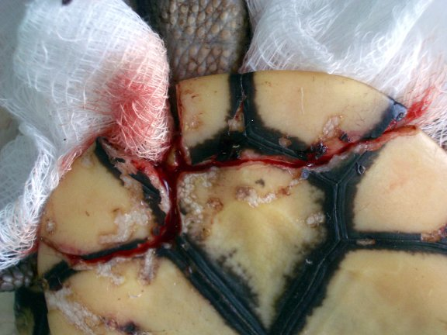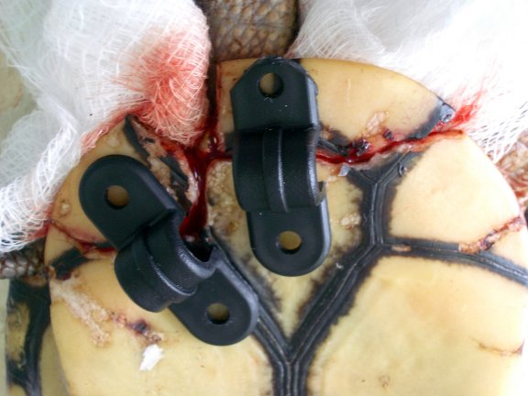

*Figures 10 and 11. Application of plastic saddle clamps to a cranial plastron fracture in an eastern long-necked turtle (Chelodina longicollis). The fractured edges have been debrided under general anaesthesia. The bridge created by the clamps allows for vital access to the wound.*

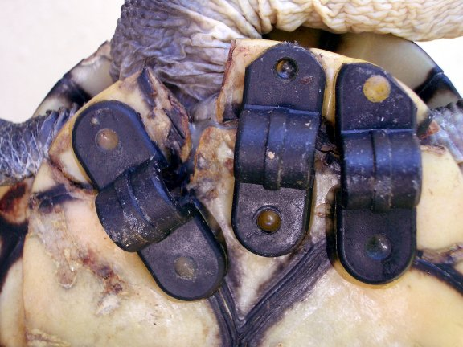

*Figure 12. Same turtle as figures 10 to 11 nine weeks later showing good fracture site healing.*

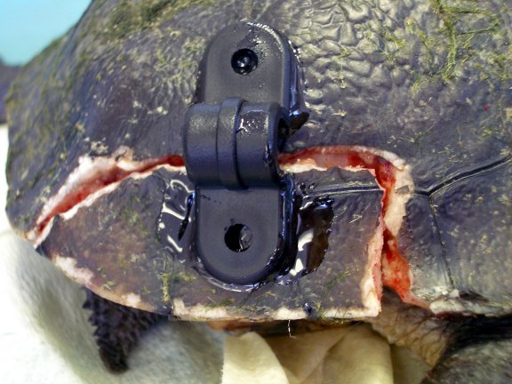

*Figures 13. Application of a plastic saddle clamp to a caudal carapace fracture in an eastern long-necked turtle (Chelodina longicollis).*

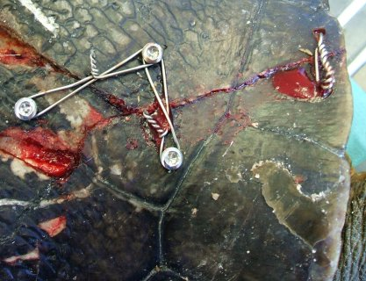

*Figure 14. Application of orthopaedic screws, cerclage wiring and shell wiring of shell fractures in a broad-shelled turtle (Macrochelodina expansa). The use of these fixation types may prove more effective in larger turtles.*

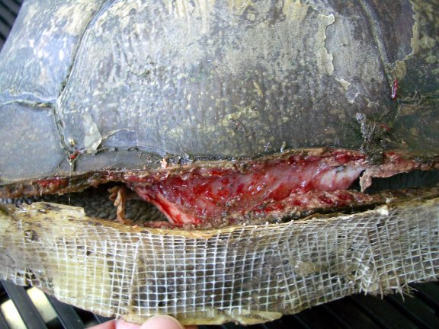

*Figure 15. Patching shell fractures with epoxies such as ‘Fibreglass’ is no longer considered an acceptable means of turtle shell repair. Removal of the epoxy from this broad-shelled turtle (Macrochelodina expansa), revealed necrotic regions of shell.*

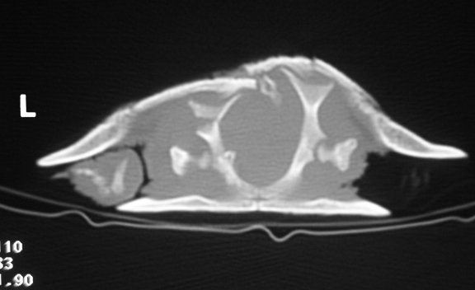

*Figure 16. Transverse CT scan through the pelvic girdle of an eastern long-necked turtle (Chelodina longicollis). Note the fracture of the left carapace and underlying fracture of the left ilium and right ventral displacement of the sacral vertebra. The vertebrae cranial to this section showed similar subluxation. The turtle had hindlimb paresis.*

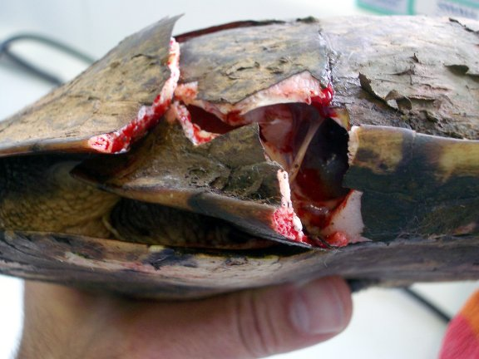

*Figure 17. Large wound with open coelom and shell deficits in an eastern long-necked turtle (Chelodina longicollis). These wounds can be difficult to treat and the prognosis for a wild turtle with such injuries is rated poor.*

**Acknowledgments**

Thanks to Dr Tina Knight BScVet BVSc for research assistance, and to Dr Shane Simpson BVSc (Hons) GCM (VP) for figure 14

**References**

1. Abou-Madi N, Scrivani PV, Kollias GV, Hernandez-Divers SM. 2004. Diagnosis of skeletal injuries in Chelonians using computed tomography. *J Zoo Wild Med.* 35(2): 226-231
2. Barten SL. 2006. Shell damage. In Mader DR. (ed) 2006. *Reptile medicine and surgery.* Elsevier Saunders, USA
3. Cann J. 1998. *Australian freshwater turtles*. Beaumont publishing, Singapore
4. Coke RL, Reyes-Fore PA, Finkelstein AD. 2005. Treatment of a carapace abscess in an Aldabra Tortoise *(Geochelone gigantea)* with negative pressure wound therapy. *Proc Assoc Rept Amphib Vet Conf* : 86
5. DeSouza R, Deconto I, Lange R, Montiani-Ferreira F. 2005. Comparison of therapeutic protocols used for shell wound repair in Red-eared sliders. *Proc Int Conf Exot.* 53-57
6. Divers S. 2000. Use of VetBioSISt skin grafting techniques in reptiles. *Proc Int Conf Exot.* 62-65
7. Forrester H, Satta J. 2005. Easy shell repair. *Exotic DVM* 6.6: 13
8. Fowler A, Magelakis N. 2004. Shell fracture repair using glass ionomer cement in the long-neck turtle (*Chelodina longicollis*). *Proc Aust Vet Assoc conf UEP SIG*. 137-139
9. Frye FL. 1973. Clinical evaluation of a rapid polymerizing epoxy resin for repair of shell defects in tortoises. *Vet Med/Sm Anim Clin.* 68: 51-53
10. Harwell G. 1989. Repair of injuries to the chelonian plastron and carapace. In Kirk RW, ed: *Current veterinary therapy 10: small animal practice*, Philadelphia WB Saunders.
11. Heard DJ. 1999. Shell repair in turtles and tortoises: An heretical approach. *Proc N Am Vet Conf*
12. Hernandez-Divers S. 2002. Scintographic imaging of a Horsfields’s tortoise with multifocal bacterial and fungal infections and plastron necrosis. *Proc Assoc Rept Amphib Vet*: 103-104
13. Hernandez-Divers S. 2004. Surgery: principles and techniques. In *BSAVA manual of reptiles (2nd Ed).* Girling SJ & Raiti P (Eds). BSAVA, UK
14. Holt PE. 1981. Healing of a surgically induced shell wound in a tortoise. *Vet Rec.* 108: 102
15. Hulst F. 1997. Repair of fractured shells in freshwater turtles*.* In*Wildlife & ferrets timeout, PGFVS*: 115-119
16. Jackson OF. 1978. Tortoise shell repair over two years. *Vet Rec*. 102: 284-285
17. Johnson J. 2002. How to repair chelonian shell disruptions. *Proc West Vet Conf*
18. Kishimori J, Lewbart G, Marcellin-Little D, Roe S. Trogdon M, Henson H, Stoskopf M. 2001. Chelonian shell fracture repair techniques. *Exotic DVM* 3.5: 35-41
19. Lafortune M, Wellehan JFX, Heard DJ, Rooney-DelPino E, Fiorello CV, Jacobson E. 2005. Vacuum-assisted closure (turtle VAC) in the management of traumatic shell defects in Chelonians. *J Herp Med Surg*. 15(4): 4-8
20. Mathews KA, Binington AG. 2002. Wound management using honey. *Compend Contin Educ Pract Vet*. 24(1): 53-60
21. McArthur S, Hernandez-Divers S. 2004. Surgery. In *Medicine and surgery of tortoises and turtles*. McArthur S, Wilkinson R & Meyer J (Eds). Blackwell publishing, Oxford UK
22. Mitchell MA. 2002. Diagnosis and management of reptile orthopedic injuries. *Vet Clin N Am Exot Anim Pract.* 5(1): 97-114
23. Mitchell MA, Diaz-Figueroa O. 2004. Wound management in reptiles. *Vet Clin N Am Exot Anim Pract*. 7(1): 123-140
24. Norton TM. 2005. Chelonian Emergency and Critical Care. [*Semin in Avian and Exotic Pet Med*. 14(2):](http://www.sciencedirect.com.ezproxy.library.usyd.edu.au/science?_ob=JournalURL&_cdi=13165&_auth=y&_acct=C000008818&_version=1&_urlVersion=0&_userid=115085&md5=f16fc9eb84e83a3850a68ffec0e3d4a2) 106-130
25. O’Malley B. 2005. *Clinical anatomy and physiology of exotic species*. *Structure and function of mammals, birds, reptiles and amphibians*. Elsevier Saunders, USA
26. Reiss A. 1999. Shell repair in tortoises and turtles. *In Wildlife in Australia. Healthcare and management. PGFVS Proc* 327: 110-111
27. Richards J. 2001. Metal bridges- a new technique of turtle shell repair. *J Herp Med Surg.* 11(4): 31-34
28. Strachan D. 1996. Topical therapy of wounds. *Aust Vet Pract*. 26(1)
29. Thomson S. www.carettochelys.com (last accessed June 2006)
30. Vella D. 2004. Reptile therapeutics. *Proc UEP Conf*. 132-144
31. Vella D. 2005. *WIRES reptile and amphibian rescue, rehabilitation and release training manual*. WIRES inc
32. Walsh MT. 1997. Sea turtle critical care principles: Application to other aquatic reptiles. *Proc N Am Vet Conf*: 761
33. Watt P. 2005. Wound Care. *Urgency in Emergency. Emergency medicine and critical care*. *PGFVS proc* 358: 321-339
34. Wilson G, Burns P. 2000. The use of a low exothermic-curing dental acrylic to repair turtle shell injuries. *Aust Vet Pract*. 30(2): 63-66
35. Zeman WV, Falco FG, Falco JJ. 1967. [Repair of the carapace of a box turtle using a polyester resin.](http://scholar.google.com/url?sa=U&q=http://www.ncbi.nlm.nih.gov/entrez/query.fcgi%3Fcmd%3DRetrieve%26db%3DPubMed%26list_uids%3D4228101%26dopt%3DCitation) *Lab Anim Care* 17(4) ; 424-425
36. Zwart P, Lambrechts L. 2001. Bone formation form scar tissue subsequent to plastrotomy in a spur-thighed tortoise - observations from the field. Exotic DVM. 3(2): 5-6

The Veterinarian (Sydney Magazine Publishers Pty Ltd). All rights reserved.  
PO Box 5068 South Turramurra  
NSW Australia 2074  
+61 2 9941 2400